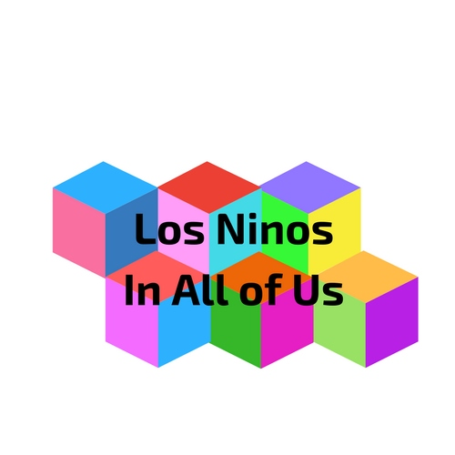

**Our greatest impact is to offer a glimmer of hope for kids in need, longer than a moment!**



Help Us

Help You

Winter Coat Drive

Newsletter

Contact Info

Backpack Challenge

Toy Drive Challenge

Pro bono

Sponsorship

Referrals

Sponsors

Partners

Toy Party & Silent Auction

Backpack in the Park

School Lunch Debt Relief

Educational Scholarships

Summer Camp Scholarships

Winter Blanket Drive

Videos

Testimonials

Reel-to-Real

Programs

Beneficiaries

Volunteer

Individual

Committees

Contact Us

Board of Directors

Staff

History

Mission

About Us



**Los Ninos In All of Us** is also known as Los Ninos and was created in 2007. Los Ninos is a U.S. 501 (c) (3) exempt nonprofit, our employer identification number (EIN) is 81-4968142.

**Mission Statement**

Our Mission is to improve the lives of our Children by giving hope for those that are in need.

**Programs**

We will accomplish this by focusing on several components;

**Spring**

* Educational Scholarship for Summer Camp (must be focused for educational development)
* Educational Scholarships for Higher Education

**Summer**

* Back Pack in The Park (Start planning in February 2018. deliver in July)

**Fall**

* Winter Coat Drive (Start planning in August. Deliver in November)
* Winter Blanket Drive (Start planning in August. Deliver in November)

**Winter**

* Toy Party (Start planning in July. Event on December 3. Disbursing December 11-20)

**Yearly**

* Assist to payoff school lunch debt (Preschool – 12th Grade)

**Leadership Qualities**

Every program we offer will develop and enable leadership qualities that prepares every child the opportunity to succeed as leaders. We believe that “No” child should be left behind because of monetary disadvantages. They consist of

* Accountability
* Authenticity
* Communication
* Confidence
* Decisiveness
* Empowerment
* Focus
* Generosity
* Innovation
* Insightfulness
* Inspiration
* Integrity
* Mentorship
* Open-mindedness
* Passion
* Patience
* Persistence
* Positivity
* Restlessness
* Transparency



**Funding Sources**

We subsidize our funding through individuals, public, private, grants, government and corporate sources, pro bono, donated items, volunteers and other legal resources.

Making sure that every child has the resources to evolve. We have developed The Education & Workforce Development Pathway which focuses on education as a powerful instrument in poverty reduction and a principal component to achieving lasting social and economic development. This pathway allows us to openly discuss and provide solutions that evolves to positive efforts to build effective educational opportunities, which ranges from early childhood education to work-ready skills programs—while exploring how education can provide the knowledge and skills necessary for people to lead vigorous, sustaining, and inspired lives.

**Toy Party  
Save the date: December 2, 2018 at 5:00 – 9:00 p.m.**



**A close up of a toy store

Description generated with high confidenceOur Toy Story - Stating Our Case**

At Los Ninos In All of Us, poverty is taken seriously. It is not a social benefit, it’s a massive problem in our society. When we ponder poverty as a burden, it becomes an economic disaster for generations to come. It destroys families and the future of our children.

Children are a major commodity of our future’s most valuable resources.  Today’s children are tomorrow’s leaders. About 15 million children in the United States – 21% of all children – live in families with incomes below the federal poverty threshold, a measurement that has been shown to underestimate the needs of families. Research shows that, on average, families need an income of about twice that level to cover basic expenses.

A child has no choice to a positive path to follow to the future. Los Ninos will pave their only pathway to lead them to a productive life as an asset to our communities. The other path leads to a life of dependency on the community for support. Without outside help, the path of least resistance is too often the path to a life of dependency.

A new toy which millions of needy children receive each Christmas from Individuals like you and through Los Ninos In All of Us. Our goal is spot-on because we deliver a message of hope.  We help set an example for children to strive for a better future.

We are experts, who are knowledgeable to help children out of poverty by providing them the tools to enhance their positive influence on the development of a strong future.  Real stories from individuals tells us that Los Ninos In All of Us has inspired kids to grow into responsible, creative, prominent citizens and community leaders.

**Something to think about**

If you think about your own life and recall what it meant when you received a toy at Christmas, we take for granted the positive impact that a new toy had on us.  If you imagine how devastating it would have been to receive nothing while all your friends received a new toy. We tend to live in the moment and don’t realize that our own neighbors might have not received any toys during the Holiday’s because his or her family was experiencing hard times.  It is devastating to think about the impact the Holidays would be without a toy. When we think about children it becomes real by how it can impact their self-worth and future.  Some never recover and never grasp their potential. Our job is not to repeat negative history that could positively change a child’s life forever.



**Winter Blanket & Coat Drive  
October 1-31, 2018**



# Coat & Blanket Drive for kids in poverty

Los Ninos In All of Us collects clean, gently used or new coats and jackets, scarves, gloves, hats, boots, blankets and/or sleeping bags as a part of our community outreach program.

The collected donations will be distributed to kids in poverty throughout the U.S. and around the World.  These are the neediest of our communities, the forgotten and disregarded.  They live in the woods, along the river, under a bridge, on the streets, in cardboard boxes, in tent camps or spending freezing nights huddling against the back of buildings and heat grates trying to stay warm.

**A picture containing person, indoor, child, floor

Description generated with very high confidence**Partaking in the Coat and Blanket Drive is an easy way and the right thing to do for you and your family to pass along coats, jackets and blankets you no longer need while helping those most helpless kids.

Collection containers can be setup in public places, corporations, educational institutions, nonprofit and religious organizations. If you would like to host your place as a collection sites, please contact us. Ask your organization if they are participating. All collected donations will be returned to Los Ninos at the end of the drive. Members of the Los Ninos Council will take care of the rest, by distributing items to beneficiary organizations. Any donated items remaining after the distribution will be made available to the agencies who work with kids in poverty and homeless throughout the year.

**A picture containing ground, person, outdoor, bicycle

Description generated with very high confidence**The neediest of our citizens, those in poverty and homeless who live on the streets, in the woods, under the bridge, or in their cars, find the winter cold the most difficult of all the seasons to survive. Many are powerless to weather the cold and freezing temperatures of winter.

**Families with children** make up a growing number of those in poverty and homeless as people continue to lose their homes in the current financial crisis and inequality of equal pay. Winter illnesses and frostbite during especially cold weather take their toll on a population who many times are in poverty and homeless through no fault of their own. We cannot blame individuals because of greediness and heartlessness.

**A group of people posing for a photo

Description generated with very high confidence**Those wishing to make a monetary contribution in lieu of, or with their coat/blanket donations, may send a check made out to Los Ninos In All of Us (write “Coat/Blanket Drive” in Memo Section) and mail to:

**Headquarters Washington**

Los Ninos In All of US

Rainbow Blvd #xxxxxxx

Las Vegas, NV 89xxx

**A picture containing building, indoor, wall, sitting

Description generated with very high confidenceHeadquarters Nevada**

Los Ninos In All of US

Rainbow Blvd #xxxxxxx

Las Vegas, NV 89xxx

**Headquarters California**

Los Ninos In All of US

Rainbow Blvd #xxxxxxx

Las Vegas, NV 89xxx

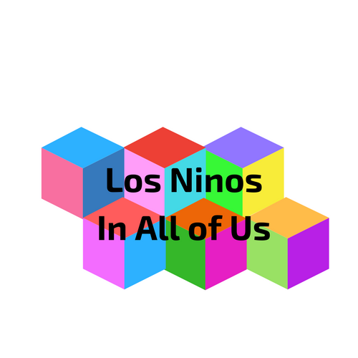

**Our greatest impact is to offer a glimmer of hope for kids in need,**

**even if it's for only a moment!**

**Become a Los Ninos patron today, and receive complimentary admission and become a VIP that you are.**



Los Ninos In All of Us

Seattle Mailing Address: 15250 32nd Ave S #69584, SeaTac, WA 98188

Las Vegas Mailing Address: 3375 S. Rainbow Blvd #80955, Las Vegas, NV 89146

Los Angeles Mailing Address: xxxx S. Los Ninos Street #12345, Los Angeles, CA xxxxx

+1 (312) xxx-xxxx

**support@los-ninos.org**

# About Us

### Not Just Any Story, It’s Your Story

**No one can write or rewrite anyone else’s story. One’s story describes a story in one’s own words. Our story is a major part of your story, because it is about you. We are a dedicated, grassroots organic group started from personal life experiences – and evolved because everyone wanted something better for ourselves and other generations.**

As kids, we had hoped and thought that our lives were like everyone else’s. The secret that we all had in common was that all of us either grew up homeless, in poverty and even middle class. The commonality that we all had in common were that we come from disadvantaged life’s. We believed life was good, so we thought.

Adulthood came upon us rapidly, even though we went on different paths. We never lost contact in 30+ years. As a circle of friends, we noticed a troubling path: the increasing number of families in the United States, Canada, Mexico and around the World struggled to make ends meet, not just month-to-month but day-to-day. A majority have parents holding a job or two and have limited public assistance. It was decided that the group would set out to raise awareness of the problem and make a meaningful difference in our communities.

Bringing a glimmer of hope, especially on Christmas mornings is a perfect sight. Los Ninos also offers Backpack in the Park, a back-to-school benefit that collects school supplies and new backpacks for students in need and those in poverty. Our programs don’t stop there, we also offer our Kids to Camp, a campaign to send children to summer STEM educational camps of their choice. Lunch is extremely important for the future of our kids to concentrate on education. We do this by helping payoff school lunch debt is something no child should have to worry about. We are proud to make sure kids are fully focused on their education, not if they can afford to eat a nutritional school lunch over their studies.

# Board of Directors

**\*\*\*Insert pictures and bios of individual board and staff members\*\*\***

**Executive Committee**

A person wearing a suit and tie smiling at the camera

Description generated with very high confidence

Chuck Obina Mendoza (President & CEO)

A person smiling for the camera

Description generated with very high confidence  
Stacè Middlebrook (Chairman of the Board)

A person smiling for the camera

Description generated with very high confidence

Breanna Speed (Treasurer)

A person wearing a suit and tie smiling at the camera

Description generated with very high confidence  
Joseph Mendoza (Secretary)

**Board of Directors** 

Beneficiaries Committee Co-chairs

1. Insert name and picture

2. Insert name and picture

Events Committee Co-chairs

1. Insert name and picture

2. Insert name and picture

Finance Committee Co-chairs

1. Insert name and picture

2. Insert name and picture

Fund Development Committee Co-chairs  
1. Insert name and picture

2. Insert name and picture

Marketing, Social Media and Communications Committee Co-chairs  
1. Insert name and picture

2. Insert name and picture

Silent Auction Committee Co-chairs

1. Insert name and picture

2. Insert name and picture

Technology Committee Co-chairs  
1. Insert name and picture

2. Insert name and picture

Volunteers Committee Co-chairs  
**1.** Insert name and picture

**2.** Insert name and picture

**Advisory Board**

**1.**

**2.**

**3.**

**4.**

**5.**

**6.**

**7.**

**8.**

# A group of kids posing for a photo Description generated with very high confidenceWho We Help

**Our Beneficiaries**

Since 2007, Los Ninos in All of Us has distributed more than 100,000 toys and gift cards through our The Toy Parties, over 25,000 backpacks filled with school supplies and gift cards through our Backpack in the Park, and raised $1,000,000’s of dollars donated to numerous kids, organizations and agencies serving Washington, Nevada, New York, California’s less fortunate.

#### Click here for the 2018 beneficiary application.

#### *The following are the types of beneficiaries we might serve and partner with*

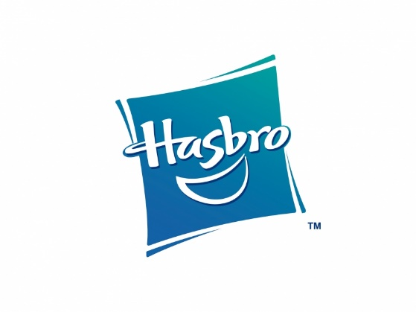 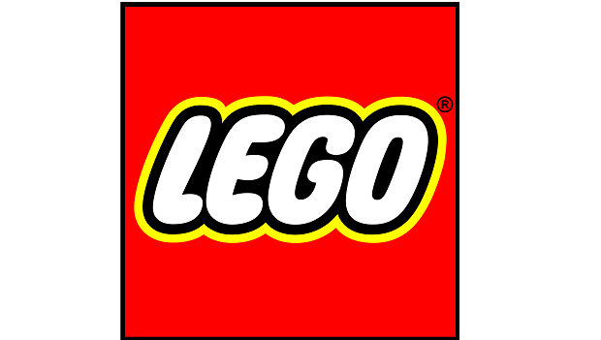 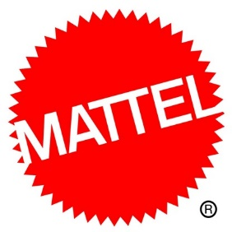 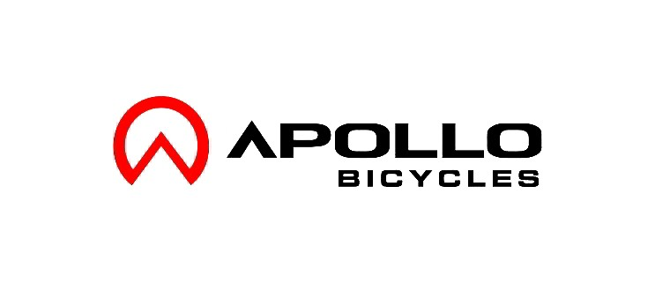 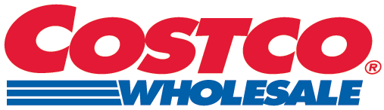 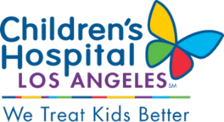 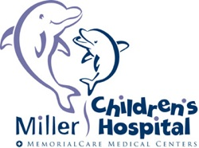 A screen shot of a boy

Description generated with very high confidence 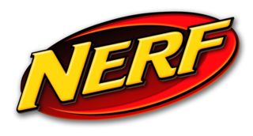How You Can Help 

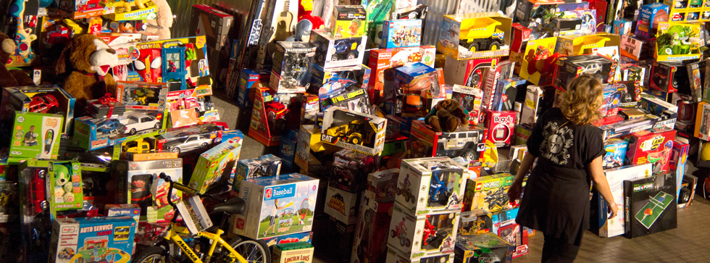

## Individual Donors

#### Mouseketeers $ 25.00

#### Building Blocks $ 100.00

#### Sand Box $ 250.00

#### Jungle Gym $ 500.00

#### Sesame Street $ 1,000.00

#### Playpen $ 2,500.00

#### Frozen $ 5,000.00

#### Dora $10,000.00

All individual donors receive year-round benefits set for each donation level at each event from the first of January through the end of December.

A screenshot of a cell phone

Description generated with very high confidence

**EMPLOYER MATCH**

Help Us Help Our Kids! Does your employer match donation gifts? Many employers support their employees’ chosen causes. Check with your employer — your gift may be doubled!

Click here for the 2018 Donor Package.

* Home
* About Us
* Who We Help
* How You Can Help
* Toy Party & Silent Auction
* Backpack in the Park
* Photos
* Contact Us

# 2017 Corporate Sponsors

You can help Los Ninos in All of Us fulfill our charitable mission by sponsoring Toy Party & Silent Auction, Backpack in the Park, and/or other campaigns throughout the year.

Corporate Sponsors will enjoy access to specially designated VIP areas at the event(s) they support. Donating companies will be listed online and included (as applicable) in promotional materials, print ads, event collateral, and venue signage.

Download the 2018 Sponsorship Package

Interested in becoming a Corporate Sponsor? Please contact support@los_ninos.org today!